**Assignment 9:** Deploy a project from GitHub to EC2.

1. Create a new EC2 instance and log in to the bitvise SSH client with the public IP address and key-value pair.
2. After log in run the command ‘sudo apt-get update’ after that run ‘sudo apt-get upgrade’



1. After that install the nginx web server in the machine by running the command ‘sudo apt-get install nginx’.



1. Then paste the public IP address of the EC2 instance in some browser and check if the page is coming or not.

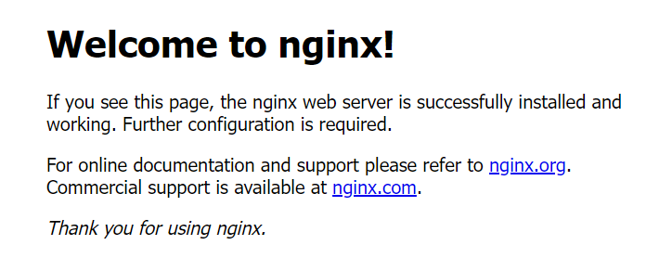

1. In order to run the project that we will be importing from GitHub we need to install node js in our machine for that run the command

* ‘curl -sL <https://deb.nodesource.com/setup_18.x|sudo> -E bash-‘ .
* ‘sudo apt-get install node js’
* ‘node -v’

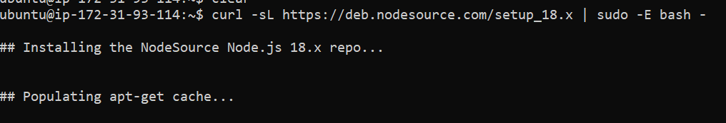





1. Now we need to clone the project repo in our own machine so run the command

‘git clone <origin link or the project>’ in our case ‘git clone <https://github.com/ishika-ghosh/awsproject.git> ‘.

Now it will ask for a GitHub username and password.

Give your GitHub username there and in the password give the access token got from GitHub.

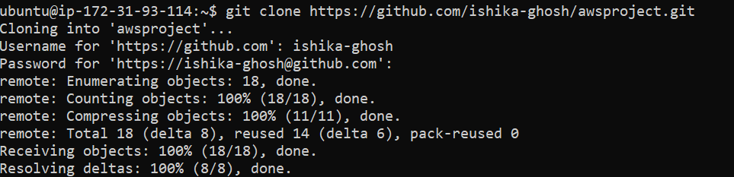

1. Now run the command ‘ls’ then go to the cloned repo and run ‘npm i’ to install all the necessary packages needed to run the project. Then to start the project run the command ‘node index.js’.

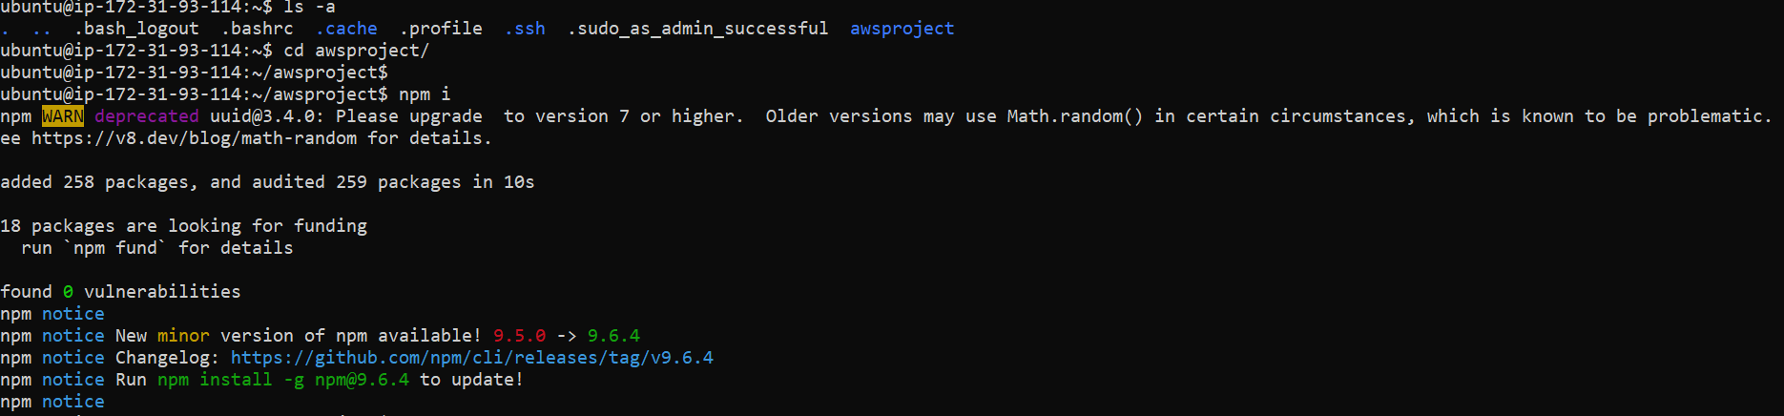

1. Now, if we refresh the browser, we will not see the response. We have to add the port number in the instance to see the response.

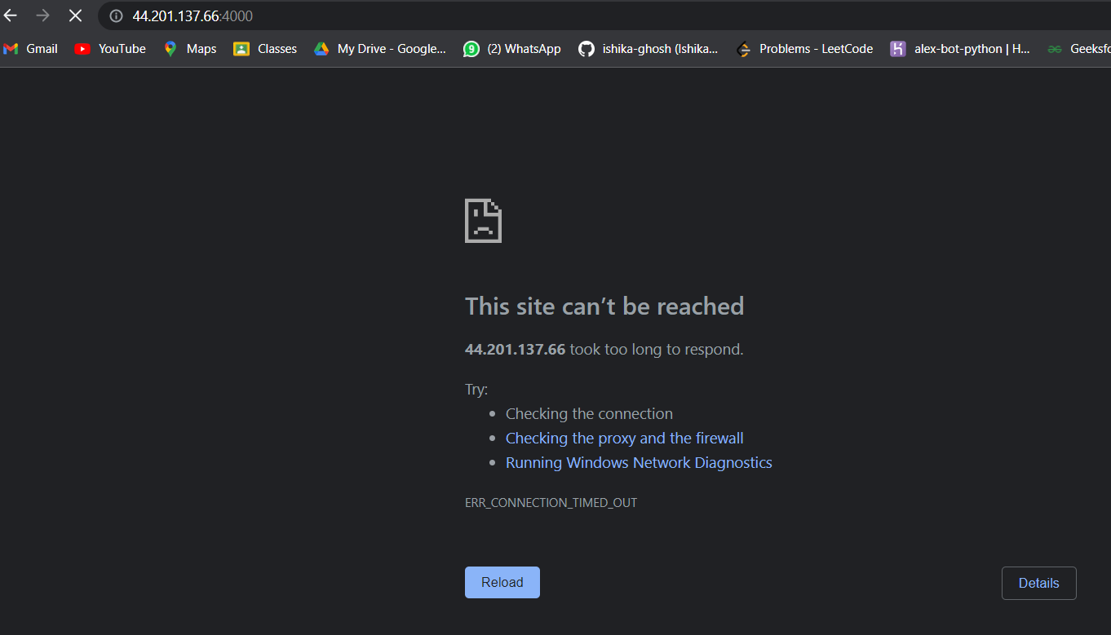

* + Go to instance security.

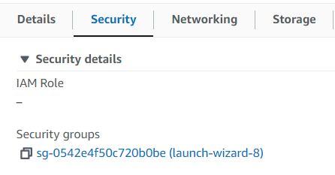

* + Then click **edit inbound rules.**



* + Then click **ADD RULE.**

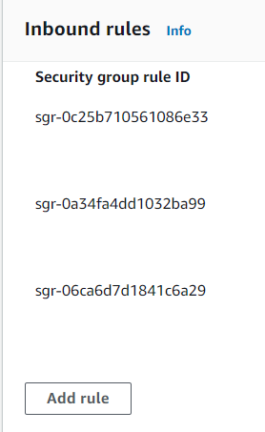

* + Give the port range 4000.
  + In the field source info select **Anywhere IPv4.**
  + Click **save rules.**

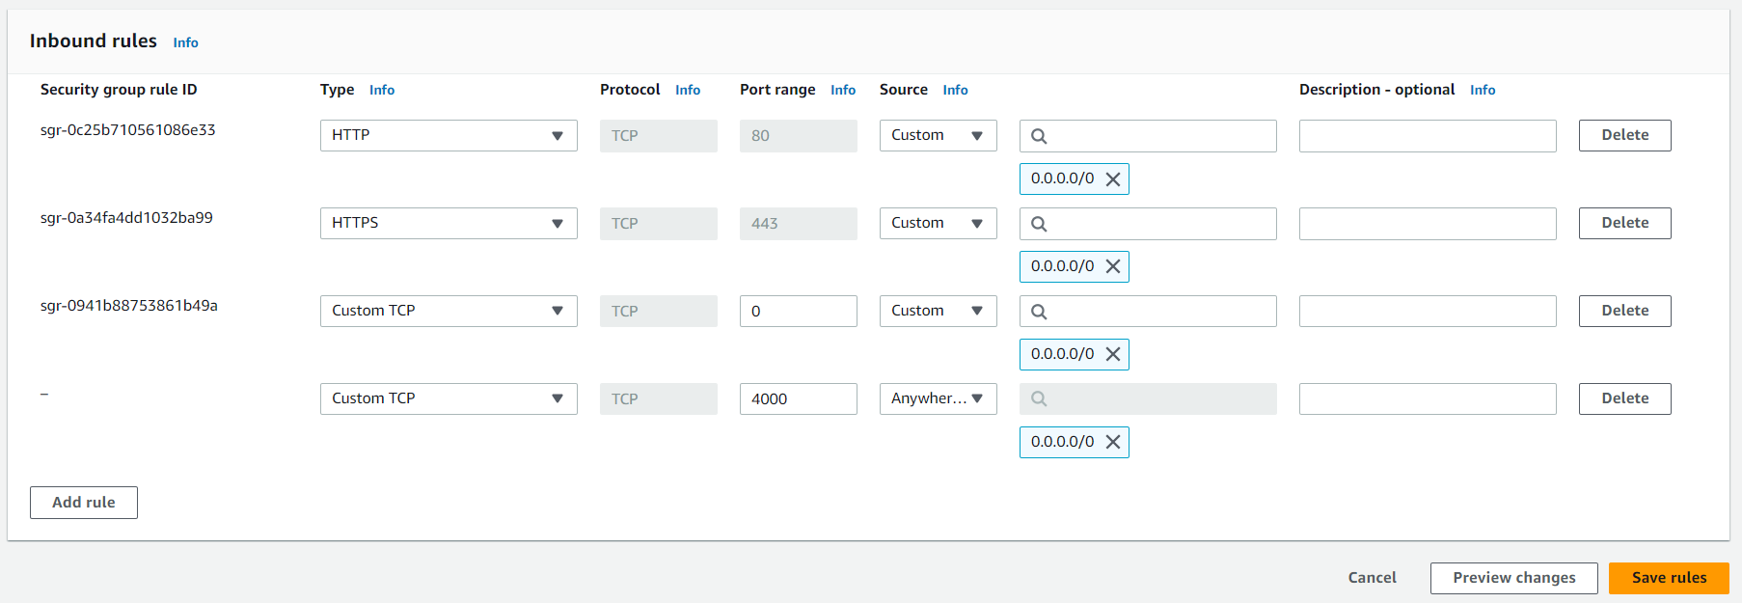

* + You will be seeing the port number in the inbound rules.

1. Now go to the browser and add a ‘:4000’ at the end of the public IP v4 address and refresh you can see the response.

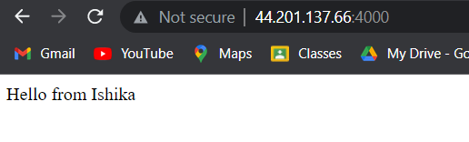

1. Now go to the GitHub repo and change something in the index.js.

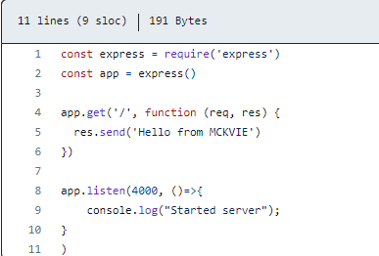

Then come back to the terminal and terminate the currently running program.

Then run ‘git pull’ and pull the changes from the GitHub then again start the index.js using ‘node index.js’.

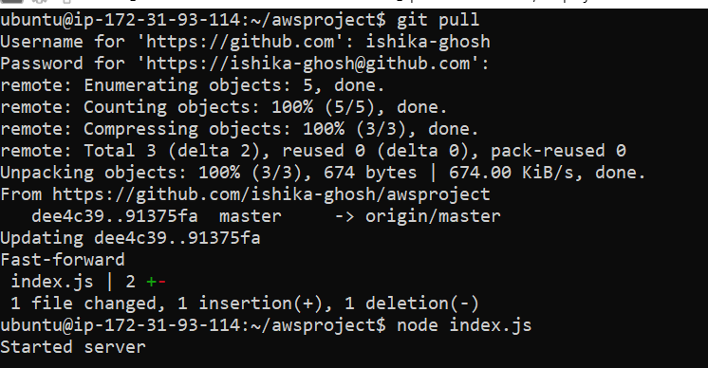

1. Now go to the browser and refresh to see the change.

